Whitehouse Primary School

Online Safety Newsletter: February 2020

YouTube: Restricted mode

Does your child use YouTube? Have you set up the restricted mode? Restricted Mode (available on the website and app) allows the user to restrict access to mature or objectionable content.

Childnet have produced a parent’s guide to YouTube Restricted Mode, which illustrates how it works and what you should be aware of:

https://www.childnet.com/blog/a-parents-guide-to-youtube-restricted-mode

Remember that this mode may not be 100% effective.

YouTube Kids may be a safer option for your family as it provides additional settings such as a content filter by age as well as providing a more contained environment.
Safer Internet Day 2020

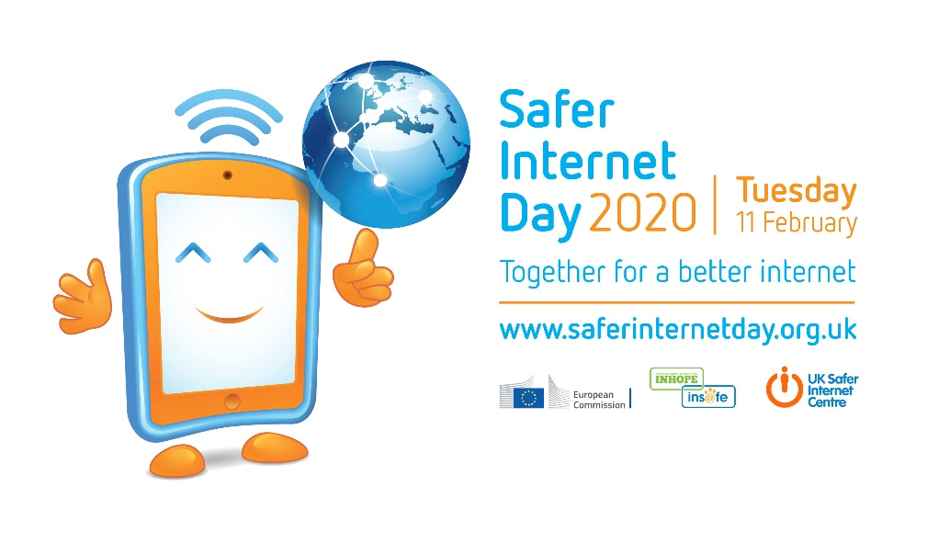

Safer Internet Day (SID) is on the 11th February this year and will be celebrated globally with the theme:
Together for a better internet

What is Safer Internet Day?

Safer Internet Day is coordinated in the UK by the UK Safer Internet Centre but is celebrated across the globe. Its aim is to inspire a conversation about using technology responsibly and urges parents, schools and other organisations to get involved.

Resources for parents

The UK Safer Internet Centre have produced a series of short films for SID in which they asked young people to give their advice for parents/carers about how they can talk to their children about their online lives. The clips are available to watch here:

https://www.saferinternet.org.uk/safer-internet-day/safer-internet-day-2020/i-am-parent-or-carer/film-how-can-parents-talk-children

We hope you can get involved on the 11th February!

Users of this guide do so at their own discretion. No liability is entered into. Current as of the date released 1.2.20.

Apple iOS: Parental controls update
Hollie Guard App

The Hollie Guard app works on iPhone, Android and Windows devices. The app allows you to keep an eye on your children while they are traveling to and from school using the Journey feature, so whenever they use this feature, their emergency contacts (you) are informed about where they’re going.

Users can also use this app to get help quickly while out if they’re in danger. If a user is in danger, they shake or tap their phone, which activates Hollie Guard and automatically sends their location and audio/video evidence to their designated contacts. Visit their website for further information or to register your interest:

https://hollieguard.com/

If your child has an Apple device then you/they have probably updated their device to iOS 13.3 by now. Did you know that this update included two new screen time features for parents?

Communication limits

This new feature allows you to limit who your child can call, FaceTime or Message during allowed screen time and during downtime. During allowed screen time, users can be contacted by everyone or by contacts only, which prevents unknown contacts from contacting them.

You will need to go to Settings - Screen Time - Communication Limits to set up. iCloud syncing of Contacts must be enabled for this feature to work

Contact list

The contact list for children lets parents/carers manage their child’s contacts on their child’s devices.

The above two features are in addition to the parental controls offered by Apple. To set up parental controls or for further information about all of the other parental controls available (such as preventing explicit content) then visit Apple’s website here:

https://support.apple.com/en-gb/HT201304
Childline have created this area, which includes activities, tools, games and videos. Its aim is to give you ideas to make you feel calmer when you are stressed or anxious.

https://www.childline.org.uk/toolbox/calm-zone/

Childline Calm zone

