Whitehouse Primary School
Users of this guide do so at their own discretion. No liability is entered into. Current as of the date released 1.1.20.

Online Safety Newsletter: January 2020
New device?
Let’s go online together!

Why not go online with your child and combine learning and fun! Oxford Owl have an area on their website full of activities for your child:

https://www.oxfordowl.co.uk/welcome-back/for-home/reading-owl/kids-activities

It also has a free eBook Library developed for children aged 3–11 years old. You can use these books to help your child learn to read and develop a love for reading. There are over 100 eBooks available:
https://www.oxfordowl.co.uk/for-home/find-a-book/library-page/

Smart Phones

Did your child get a new smart phone for Christmas or are they using yours? Have you made sure that the correct parental controls have been set up to help protect your child whilst using the device?

Example controls include setting the device so only age appropriate apps can be downloaded and the ability to disable in-app purchasing (or don’t store your payment card details) to avoid any hefty bills.

iPhone advice: https://support.apple.com/en-gb/HT201304
Android advice: https://www.internetmatters.org/parental-controls/smartphones-and-other-devices/android-smartphone/

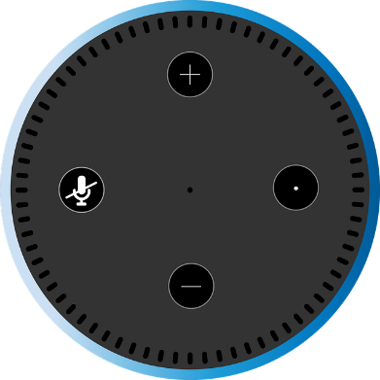
Smart speaker

Have you invested in a smart speaker for your home? “Hey, Google” or “Alexa, play some music” may be your key commands now but have you set up the correct parental controls? For example, when using a supervised account on a Google nest, children can't make purchases.

Google Nest: https://support.google.com/googlenest/answer/9039704?hl=en-gb&ref_topic=7196250
Start a conversation!

Question?
Who would you talk to if you saw something online that upset you?

Amazon Echo: https://www.commonsensemedia.org/blog/how-to-set-parental-controls-on-the-amazon-echo
Is this fake news?

This is a handy guide designed to help you support your child in developing their critical thinking and digital literacy skills when spotting fake information online. Read the guide here:
https://www.internetmatters.org/resources/tackling-fake-news-misinformation-advice-for-parents/

Minecraft (PEGI Rating 7)

Want to learn more?

The eSafety Commissioner (Australia) has set up this dedicated area to learn more about games, apps and social media that your child might be accessing, including how to report online abuse, block somebody and links to further information. Available here:

https://www.esafety.gov.au/key-issues/esafety-guide

Minecraft continues to remain popular with it being played by 112 million people every month. It is a great learning tool and is used in schools to teach skills such as planning, problem solving, simulation and 3D modelling. Minecraft is rated as PEGI 7, which means it is suitable for players above 7 years; however, the PEGI rating does not consider the chat facility available within Minecraft. The chat facility can be switched off by following these steps:
- click ‘options’
- select multiplayer settings
WhatsApp privacy settings

Are yours and your child’s (if using) privacy settings set up appropriately? For example, you can set that only ‘my contacts’ can add you to groups and even add exceptions to this rule.

Android device: https://faq.whatsapp.com/en/android/23225461/?category=5245250

iPhone device: https://faq.whatsapp.com/en/iphone/28041111
- click on chat choose shown, hidden or commands only.

If you choose to keep the chat facility on then make sure your child knows what to do if anything upsetting happens.

In addition, protect your child’s privacy by using a nickname (don’t include their age/birth year) and also chat to your child to make sure that when playing online they know not to tell others personal information such as where they live, what school they go to and their age. More information is available here: https://parentinfo.org/article/staying-safe-on-minecraft

Instagram restrict mode

Instagram have introduced a new feature that allows users to restrict another user. You could restrict somebody (a bully for example) which means they will not be able to see when you are online or if you’ve read their messages. Also, only you (and that user) will be able to see their comments on your post. The great thing about this feature is that they won’t know that you have ‘restricted’ them. This is different to blocking (when you block somebody, you no longer see anything they do on Instagram and they don’t see anything you do either).

Learn how to use this new feature so you can show your child how to use it: https://help.instagram.com/2638385956221960

