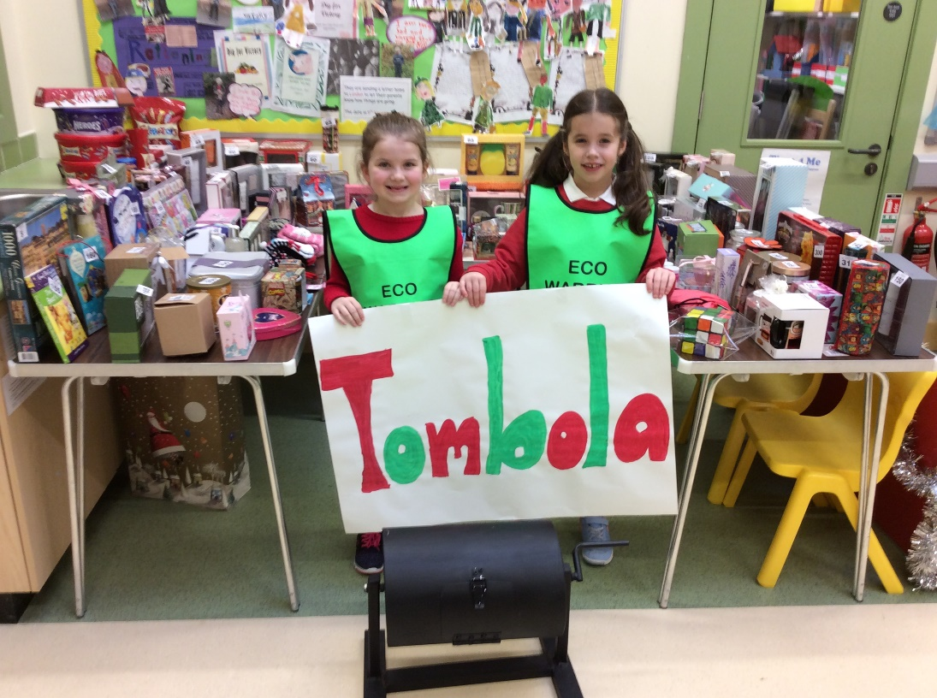
Eco team Tombola

The Eco team would like to say a HUGE thank you to each family who have sent in a prize for our Tombola. All the money raised will be used by the Eco team to buy items for the school and to help support the team.
We will be running the tombola from:
MONDAY 17th DECEMBER!
50p for one go or £1 for 3 goes.
Any ticket ending in 0 or 5 will win a prize!!!
The Eco team would like to thank you for your support!!

